COMMANDS

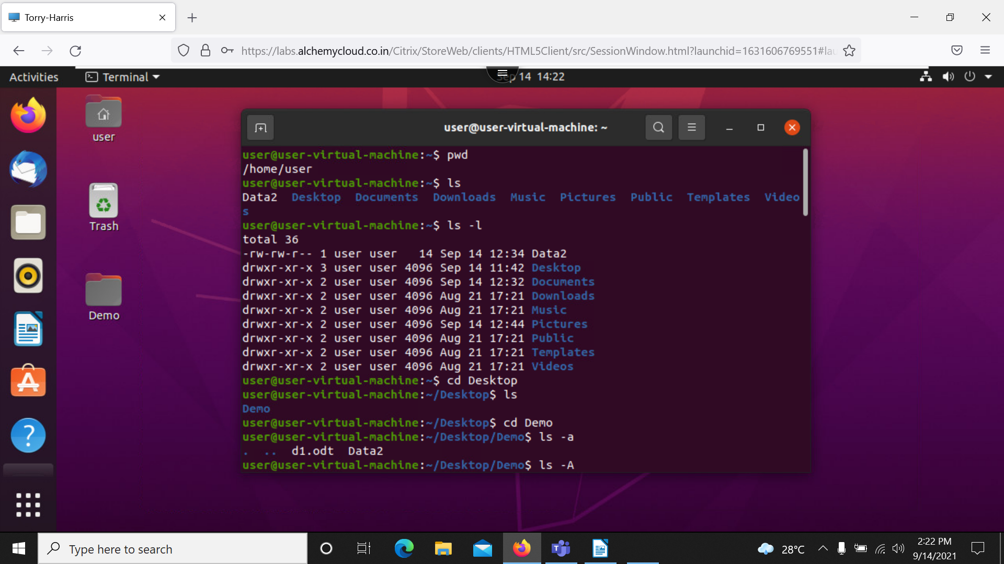

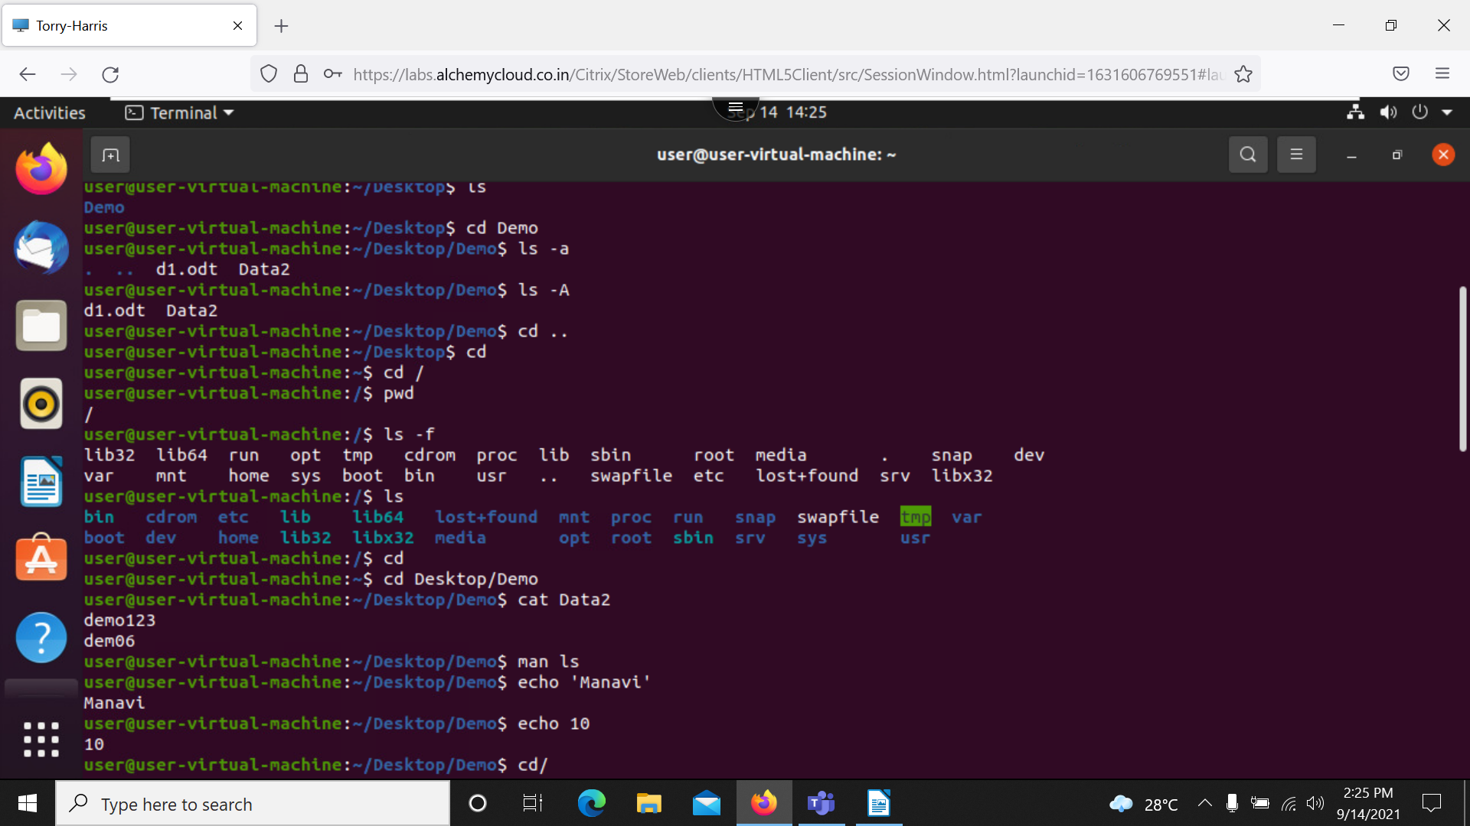

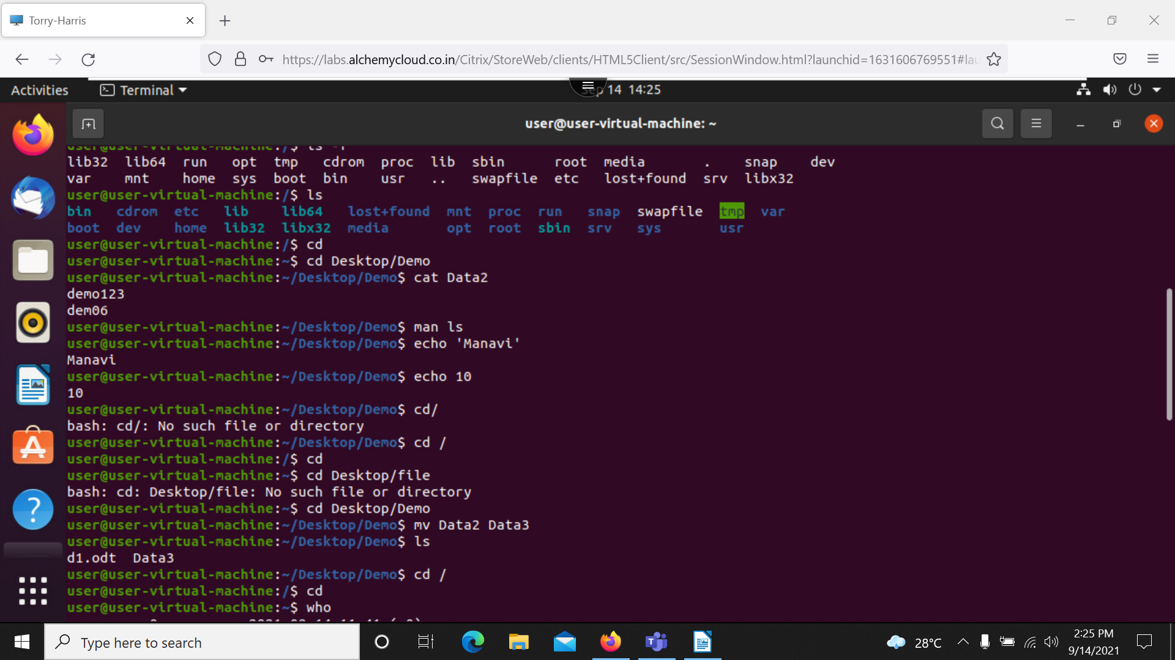

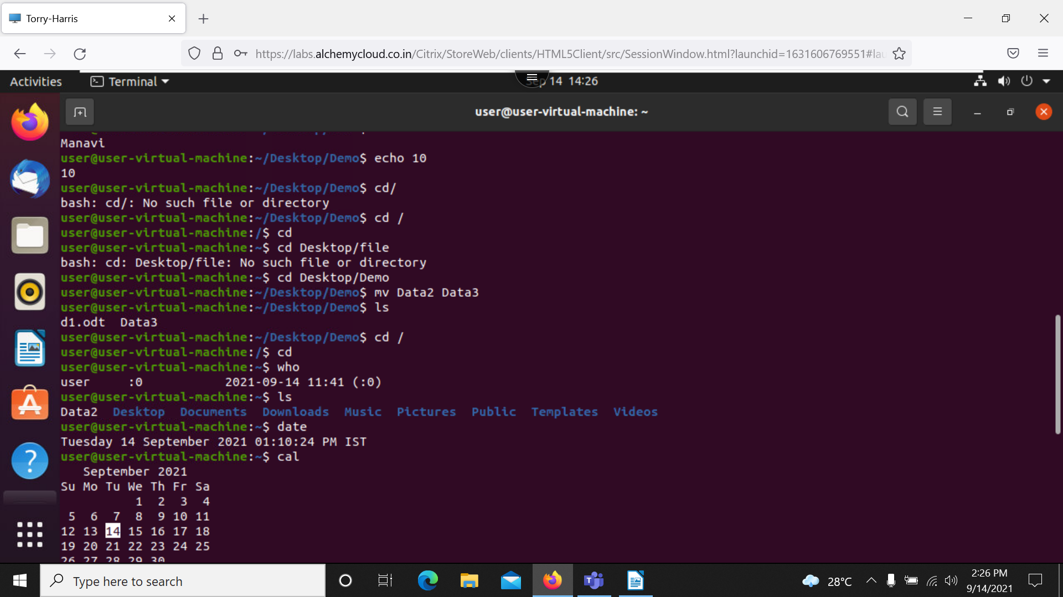

$pwd: present working directory.
~: home directory.
/: root directory.
$clear: clear screen.
$ls: list all the directory in the present working directory.
$ls -l: it display author, date, time.
cd : change directory.
.Hidden: it will hidden the file
$ls -a: to see the hidden folder
$cd ..:go one step before
$cd: getting to home directory
$cd / : access root folder.
$ls -f: display all the folders without any format along with the hidden folder.
$ls : shows all the folders in dictionary order.
$exit: close session.
Cat: we can read text file.
$cat data2: concatinate, reading the text files
$man ls: it shows all the things can we done using ls command.
$ls -A: gives us necessary files, do not show hidden file.
$echo ‘abc’: print command.
$mv data1 data2: rename the directory.
$who: it shows the user, timing.
$date: display date.
$mkdir: create directory
$rmdir: remove directory
$touch: create a file
$cp: cut and paste
$cp a z: copy the data of a to z
$tac z: reversing data in file z
$cat a b c: all the files in single time
$cat -b a: display line number
$sort: for sorting used.

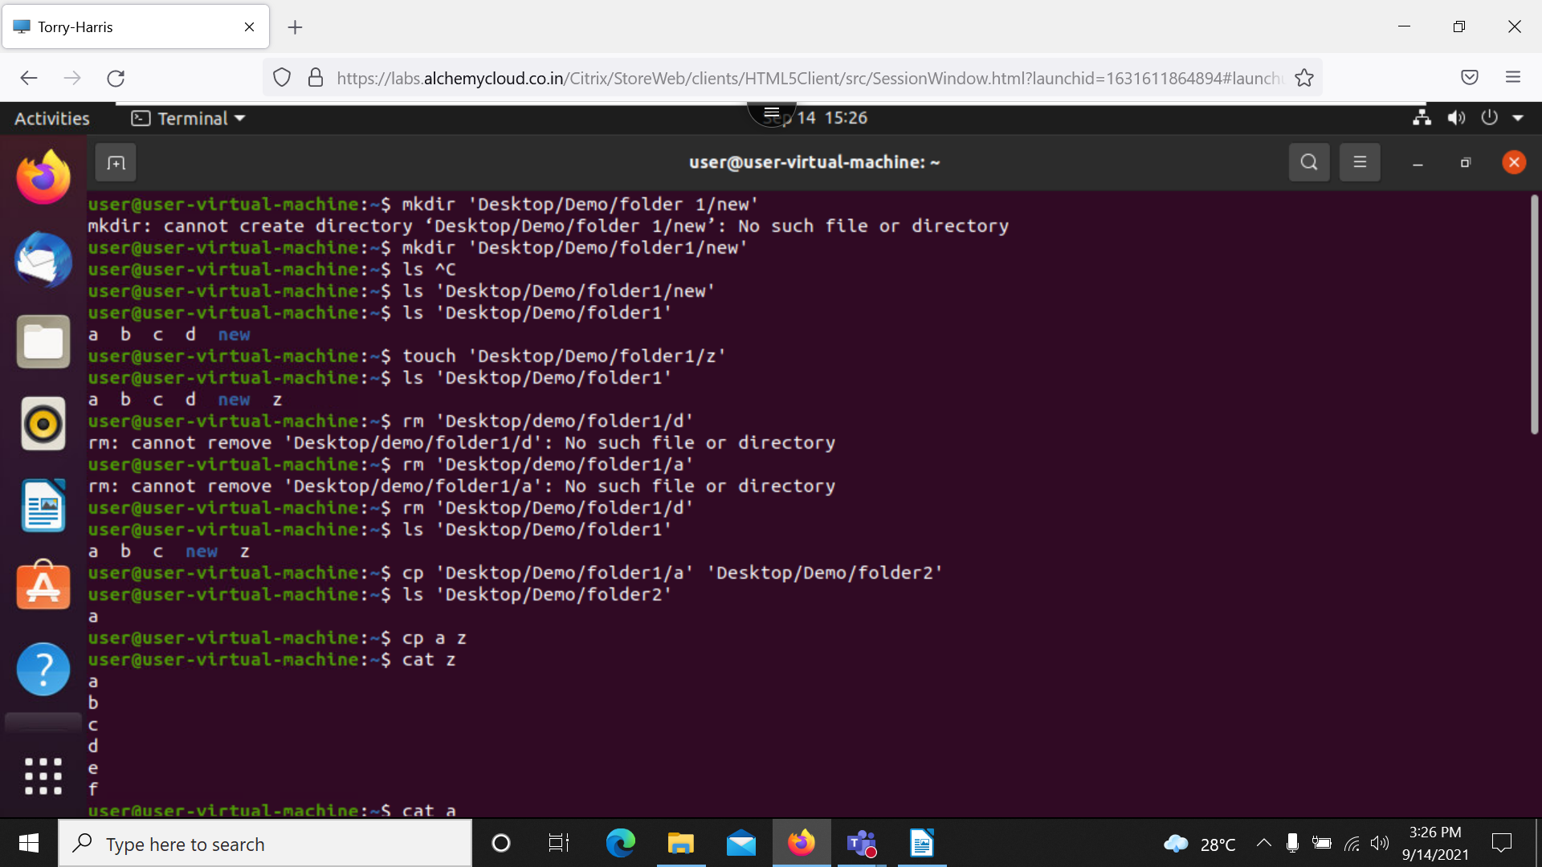

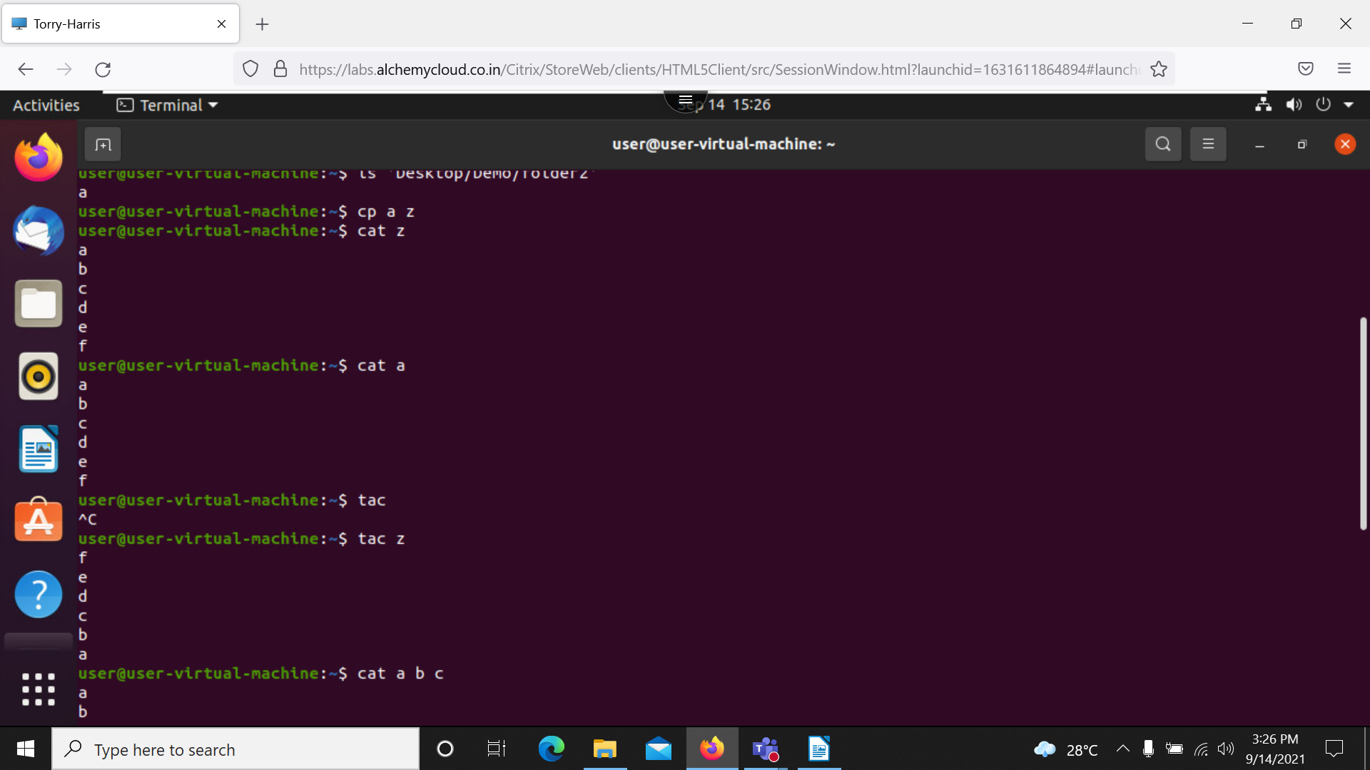

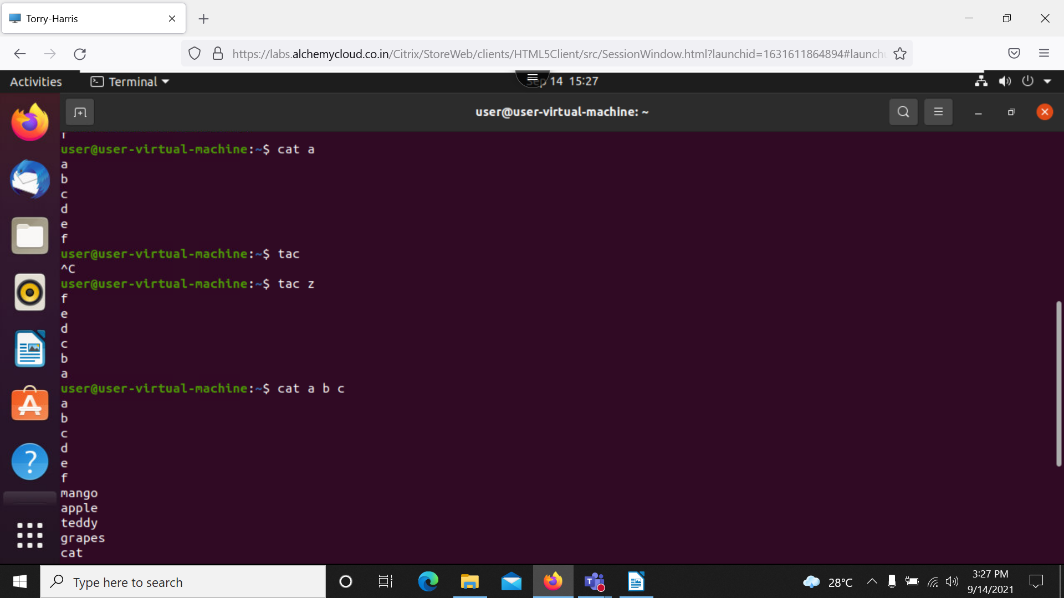

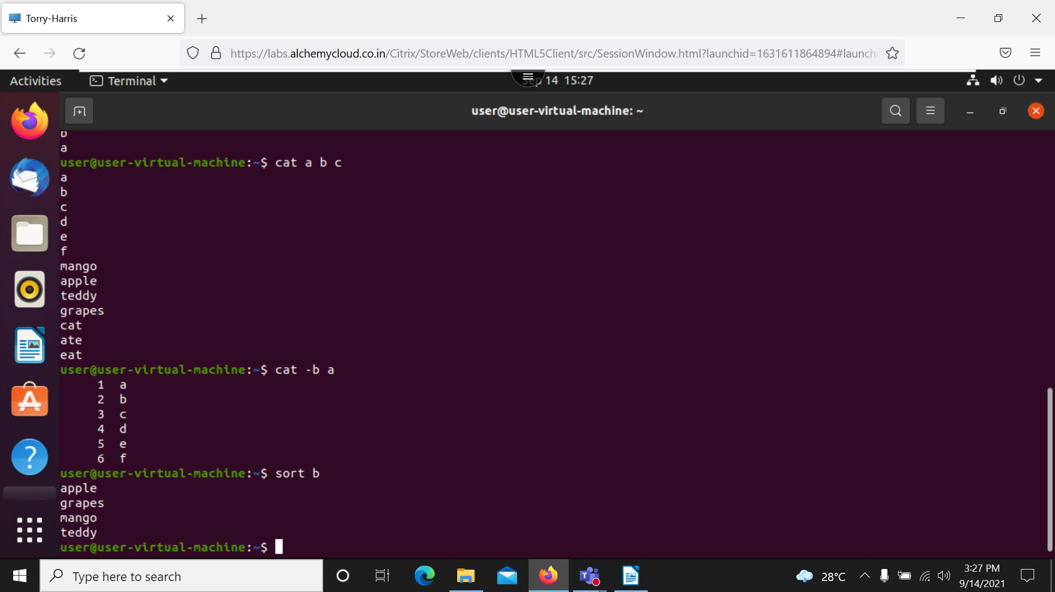

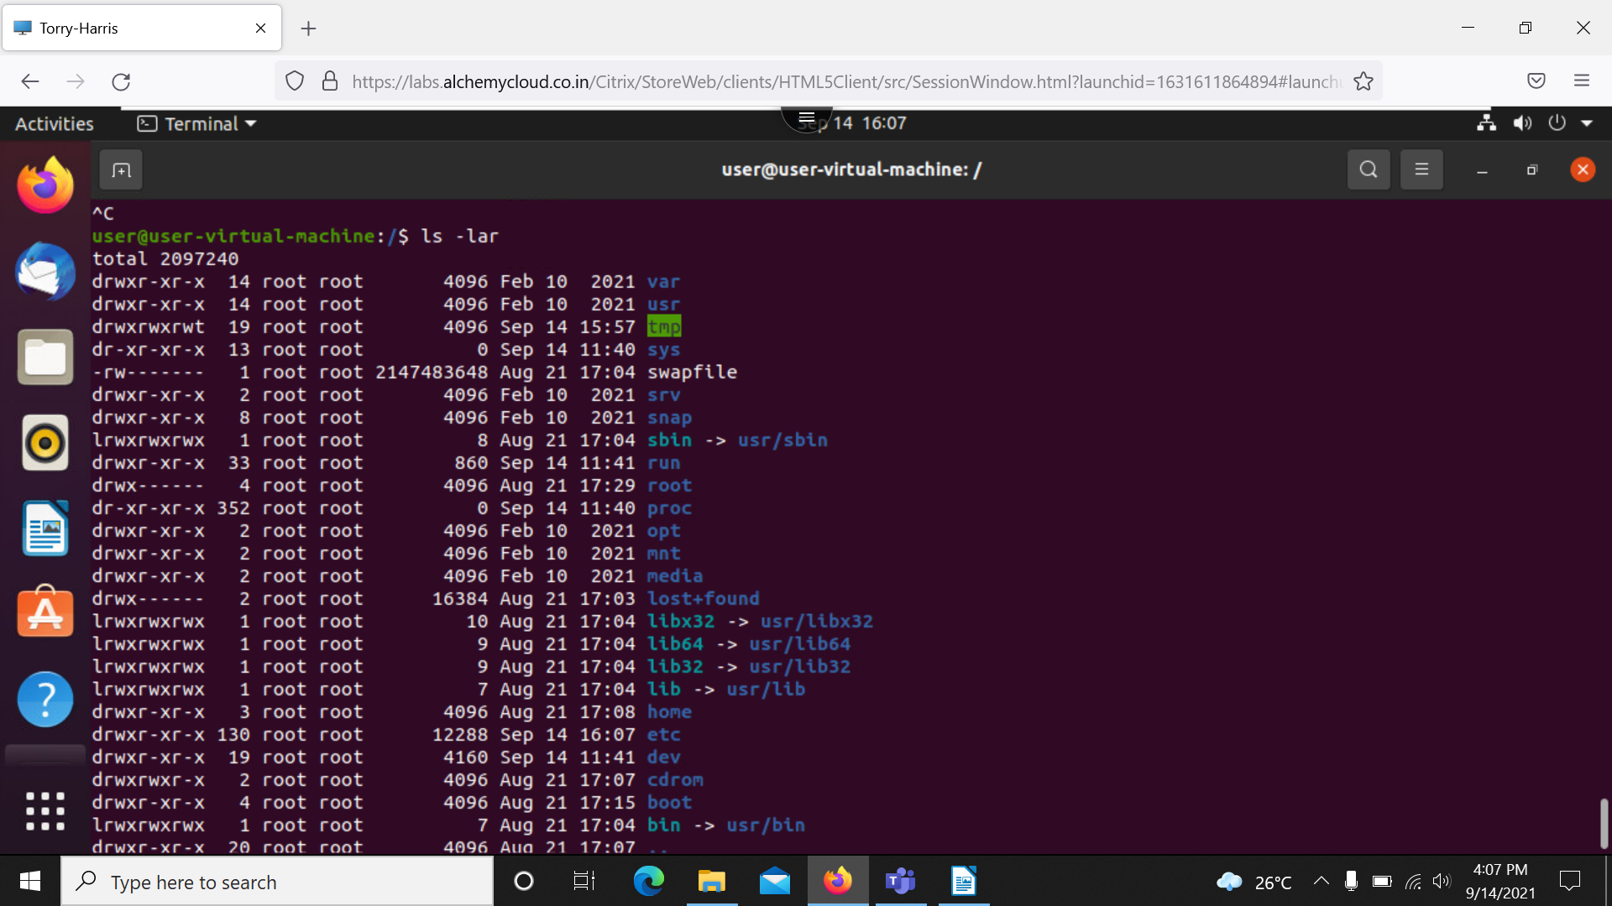

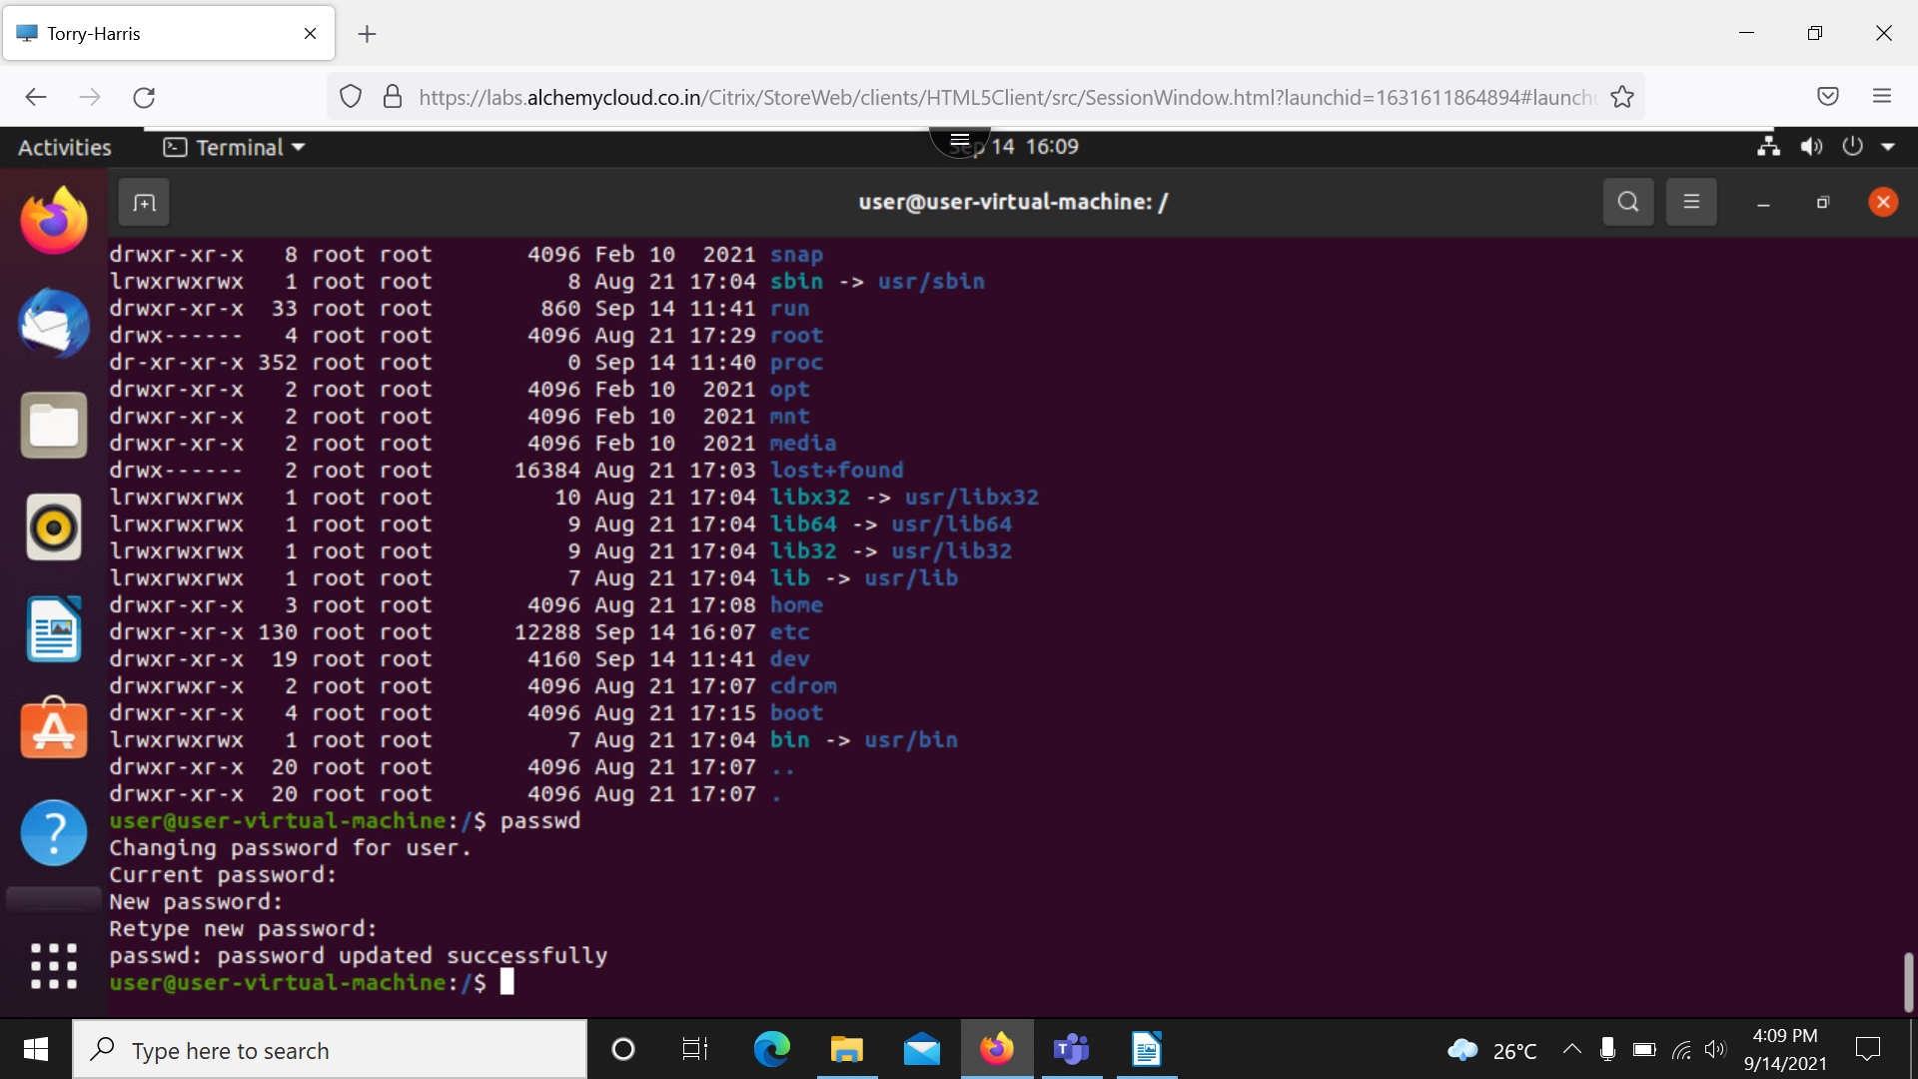

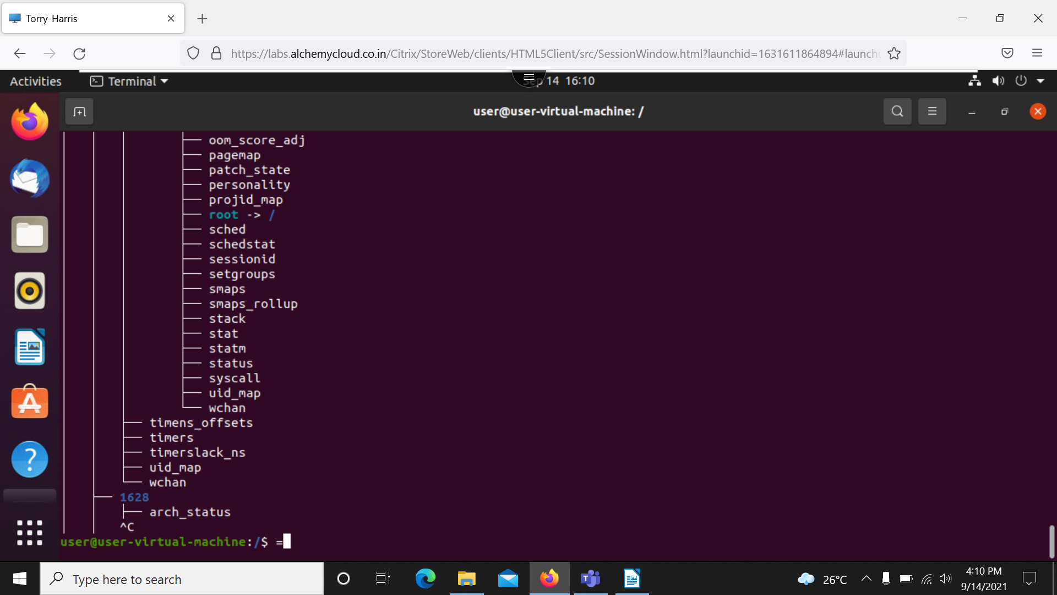

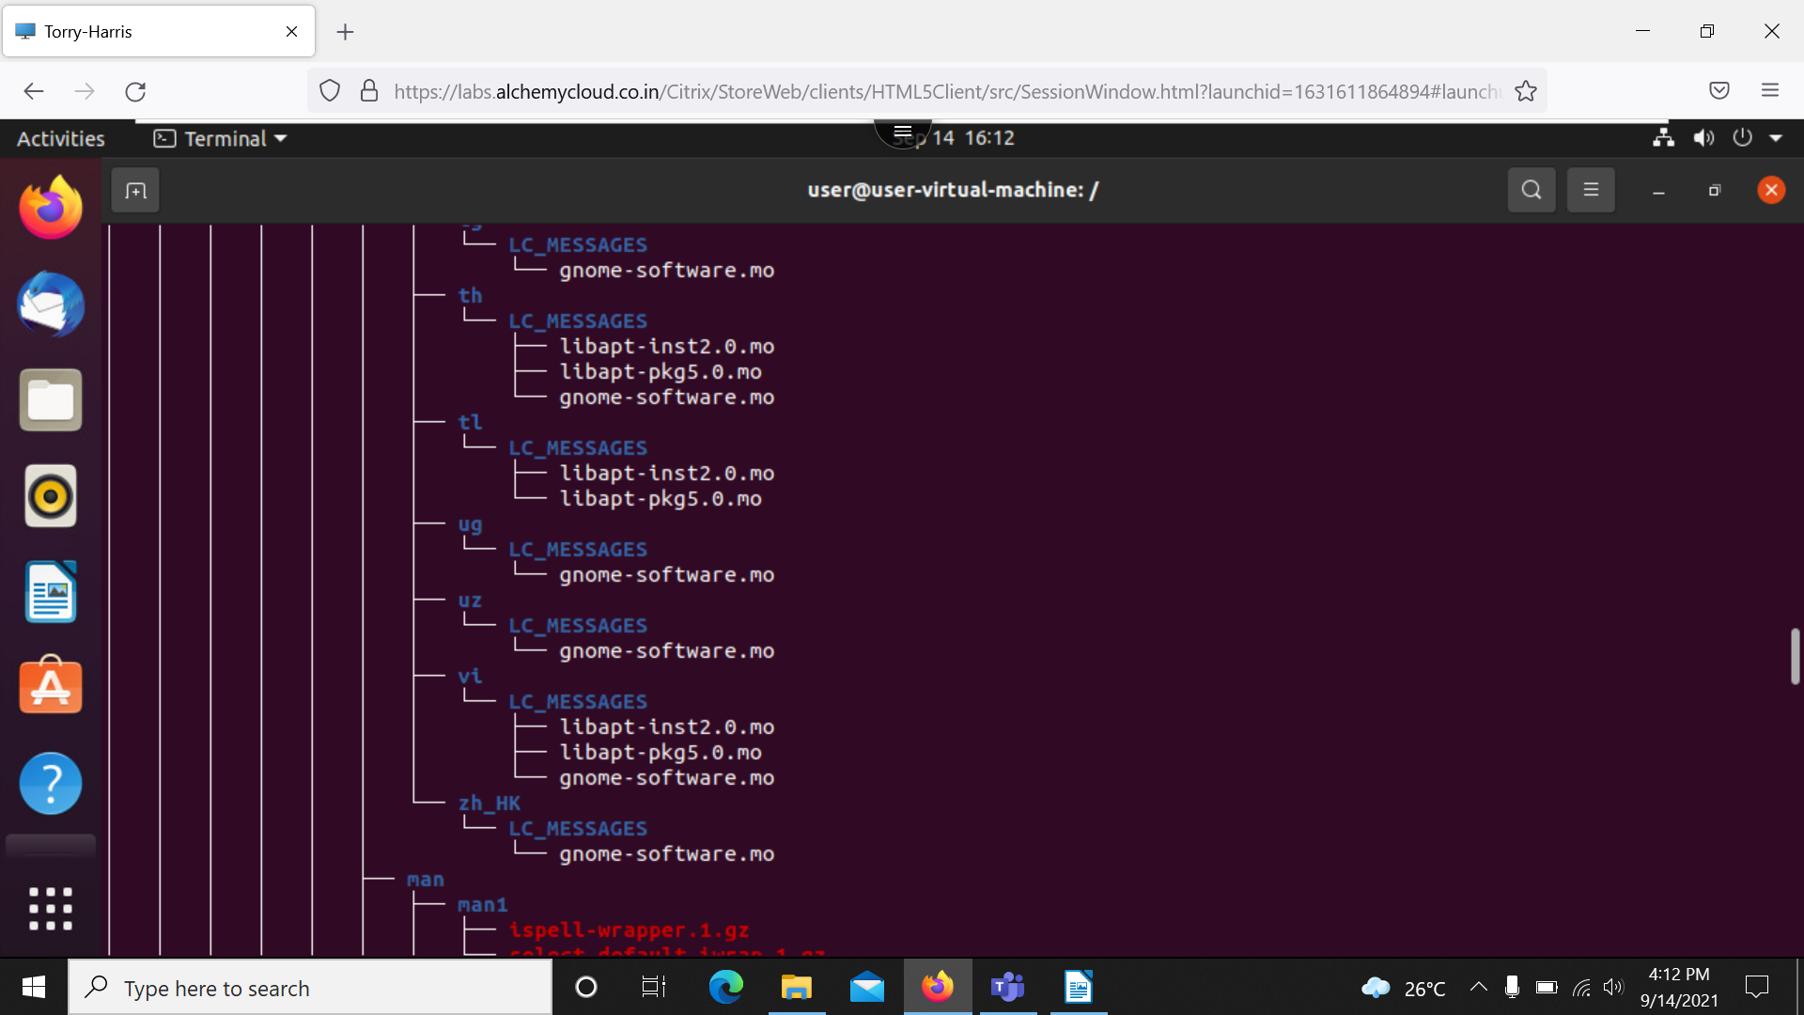

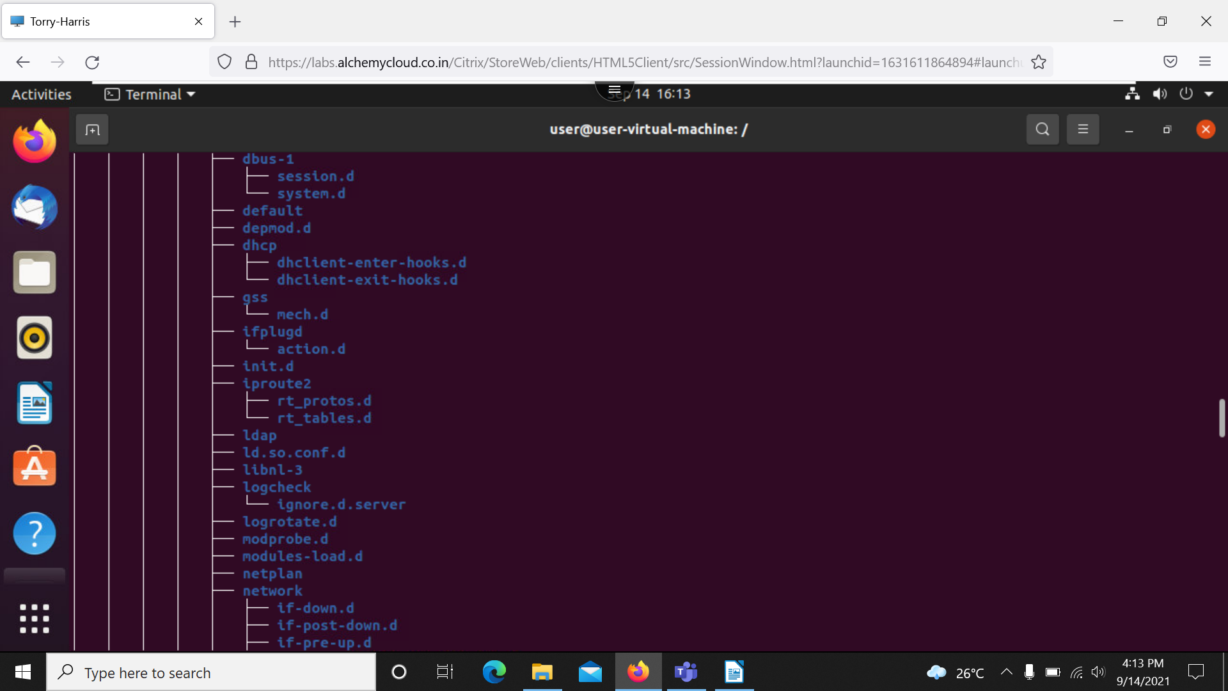

$ls -lar: reversing the list directories
$passwrd: change the password of current user
$tree: it print the hierarchy of directory
$tree -c: it displays all the directories and files in the tree
$tree -cd: it just shows the directories alone
$tree -d: it shows the folder alone

packages;
sudo apt -get update: downloading the updates
sudo apt -get upgrade: install the things
sudo apt -get update && upgrade: both downloading and installation takes place here.

